The Ministry of education and science of the Russian Federation

Ural Federal University named by the first President of Russia B.N.Yeltsin

Institute of Radioelectronics and Information Technologies

Faculty of Radioelectronics and Information Systems

**Processing images with OpenCV**

Project supervisors: Zyuzin Vasily Viktorovich

Student of group RI-440004: Wu Xuanyan (У Сюаньянь)

Yekaterinburg

2019

Topics:

1. The study of edge detectors. Implementation of the most famous algorithms for detection edges.

2. Geometrical transformation of the image (Data augmetation). Implementation 5 or more methods for geometrical transformation.

3. Tempate matching. Implementation algorithm for finding small picture (pattern) on a big image.

4. The study of adaptive methods of image thresholding (binary segmentation). Implementation 2 or more adaptive methods for binary segmentation (Isodata, Li, mean, minimum, Yen).

5. Finding objects with nessesery shape in the image (for instance, circle, rectangle, etc.).

6. Implementation of random walker segmentation.

7. Implementation of watershed segmentation.

8. Implementation of object tracking.

content

1.The study of edge detectors 4

1.1 INTRODUCTION 4

1.2 Several edge detection algorithms 4

1.3 Comparison of several operators 10

2.Tempate matching 14

3.The sudy of adaptive methods of image thresholding (binary segmentation). 14

4.Finding objects with nessesery shape in the image (for instance, circle, rectangle, etc.). 16

5.Implementation of random walker segmentation. 17

6.Implementation of watershed segmentation. 19

7. Implementation of object tracking. 21

REFERENCES 23

# 1.The study of edge detectors

The study of edge detectors. Implementation of the most famous algorithms for detection edges.

## 1.1 INTRODUCTION

In the field of digital image processing, the edge detection has a very important role in the digital image processing . Edge detection can be defined as the process localization and identification of abrupt changes in the smoothness of an image . An image is a collection of different pixels intensities which may forms edges or boundaries of an image . In edge detection technique, an image has a standard fundamental problem which consists of image segmentation and enhancement or compression and computer vision in image processing . It has been a major concerning issue in image segmentation.

For image segmentation an image can be segmented into parts and finds the abrupt change in image processing and then detect the edges of an image . In digital image processing an image has several edge detectors. Some of them are canny, Sobel, Prewitt, Log and fuzzy logic detectors useful in image edge detection, segmentation, and boundary detection in digital image processing . Each operator is designed to be sensitive to certain types of edges. Among them Sobel, Roberts, Prewitt, Log and Canny are major concerning operators. The geometry of the operator determines a characteristic direction in which it is most sensitive to edges.

## 1.2 Several edge detection algorithms

**import** cv2 **as** cv  
**import** numpy **as** np  
**def** gradient_demo():  
 src = cv.imread(**"D:/picture1/lena2.jpg"**)  
 cv.imshow(**"input"**, src)

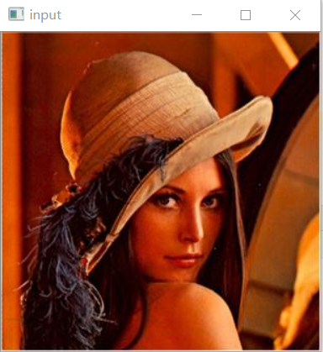

(1)The Roberts cross operator is used in image processing and computer vision for edge detection, It was one of the first edge detectors. As a differential operator, the idea behind the Roberts cross operator is to approximate the gradient of an image through discrete differentiation which is achieved by computing the sum of the squares of the differences between diagonally adjacent pixels. In order to perform edge detection with the Roberts operator we first convolve the original image, with the following two kernels:

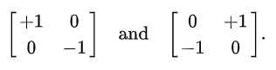

Let I(x,y) be a point in the original image and G_{x}(x,y) be a point in an image formed by convolving with the first kernel andG_{y}(x,y) be a point in an image formed by convolving with the second kernel. The gradient can then be defined as:

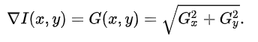

The direction of the gradient can also be defined as follows:

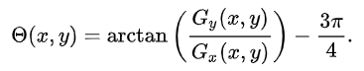

Note that angle of 0° corresponds to a vertical orientation such that the direction of maximum contrast from black to white runs from left to right on the image.  
 robert_x = np.array([[1, 0], [0, -1]])  
 robert_y = np.array([[0, -1], [1, 0]])  
 gradx1=cv.filter2D(src,cv.CV_32F,robert_x)  
 grady1=cv.filter2D(src,cv.CV_32F,robert_y)  
 gradx1 = cv.convertScaleAbs(gradx1)  
 grady1 = cv.convertScaleAbs(grady1)  
 cv.imshow(**"x-robert"**, gradx1)  
 cv.imshow(**"y-robert"**, grady1)  
 grad1 = cv.add(gradx1, grady1)  
 cv.imshow(**"robert_grad"**, grad1)

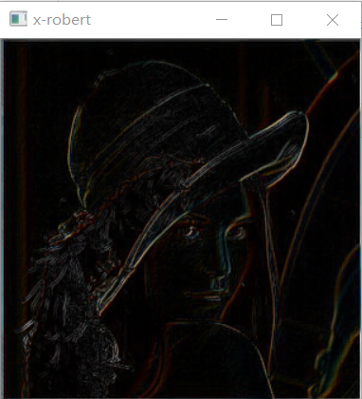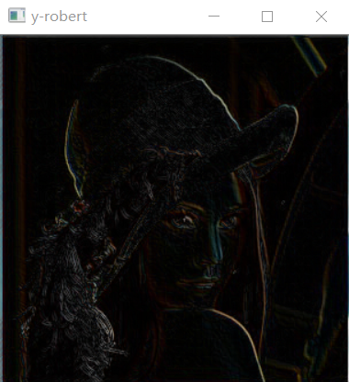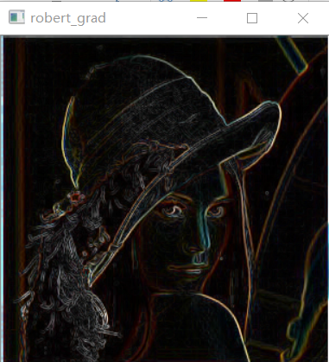  
(2) The Prewitt operator is used in image processing, particularly within edge detection algorithms. Technically, it is a discrete differentiation operator, computing an approximation of the gradient of the image intensity function. At each point in the image, the result of the Prewitt operator is either the corresponding gradient vector or the norm of this vector. The Prewitt operator is based on convolving the image with a small, separable, and integer valued filter in horizontal and vertical directions and is therefore relatively inexpensive in terms of computations like Sobel and Kayyali operators. On the other hand, the gradient approximation which it produces is relatively crude, in particular for high frequency variations in the image.

Mathematically, the operator uses two 3×3 kernels which are convolved with the original image to calculate approximations of the derivatives - one for horizontal changes, and one for vertical. If we define **A** as the source image, and **Gx** and **Gy** are two images which at each point contain the horizontal and vertical derivative approximations, the latter are computed as:

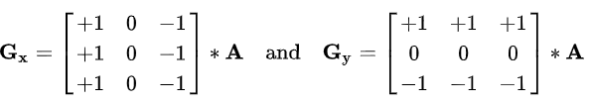

where * here denotes the 1-dimensional convolution operation.

Since the Prewitt kernels can be decomposed as the products of an averaging and a differentiation kernel, they compute the gradient with smoothing. Therefore, it is a separable filter. For example, **Gx** can be written as

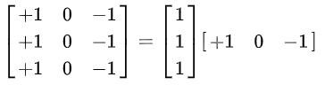

The x-coordinate is defined here as increasing in the "left"-direction, and the y-coordinate is defined as increasing in the "up"-direction. At each point in the image, the resulting gradient approximations can be combined to give the gradient magnitude, using:

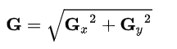

Using this information, we can also calculate the gradient's direction:

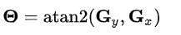

where, for example, **Θ** is 0 for a vertical edge which is darker on the right side.  
 prewitt_x = np.array([[-1, 0, 1], [-1, 0, 1], [-1, 0, 1]])  
 prewitt_y = np.array([[-1, -1, -1], [0, 0, 0], [1, 1, 1]])  
 gradx2=cv.filter2D(src,cv.CV_32F,prewitt_x)  
 grady2=cv.filter2D(src,cv.CV_32F,prewitt_y)  
 gradx2 = cv.convertScaleAbs(gradx2)  
 grady2 = cv.convertScaleAbs(grady2)  
 cv.imshow(**"x-prewitt"**, gradx2)  
 cv.imshow(**"y-prewitt"**, grady2)  
 grad2 = cv.add(gradx2, grady2)  
 cv.imshow(**"prewitt_grad"**, grad2)

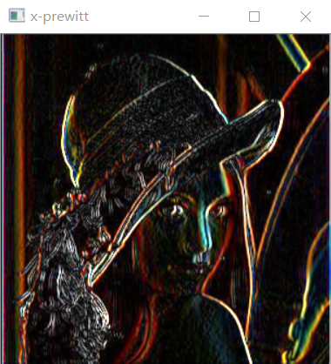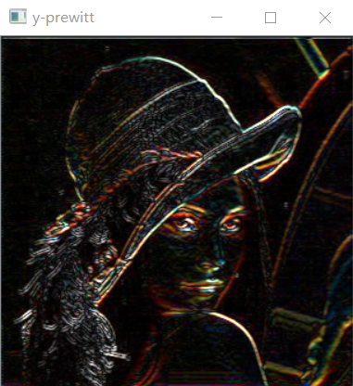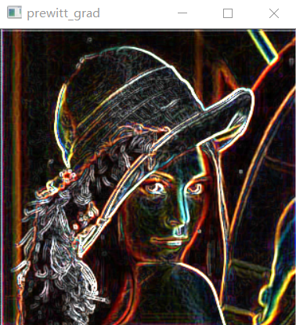  
(3)The Sobel operator, sometimes called the Sobel–Feldman operator or Sobel filter, is used in image processing and computer vision, particularly within edge detection algorithms where it creates an image emphasising edges. Technically, it is a discrete differentiation operator, computing an approximation of the gradient of the image intensity function. At each point in the image, the result of the Sobel–Feldman operator is either the corresponding gradient vector or the norm of this vector. The Sobel–Feldman operator is based on convolving the image with a small, separable, and integer-valued filter in the horizontal and vertical directions and is therefore relatively inexpensive in terms of computations. On the other hand, the gradient approximation that it produces is relatively crude, in particular for high-frequency variations in the image.

The operator uses two 3×3 kernels which are convolved with the original image to calculate approximations of the derivatives – one for horizontal changes, and one for vertical. If we define **A** as the source image, and **Gx** and **Gy** are two images which at each point contain the vertical and horizontal derivative approximations respectively, the computations are as follows:

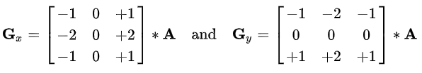

where * here denotes the 2-dimensional signal processing convolution operation.

Since the Sobel kernels can be decomposed as the products of an averaging and a differentiation kernel, they compute the gradient with smoothing. For example, **Gx** can be written as

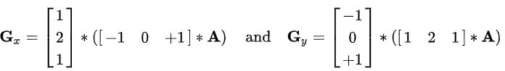

The x-coordinate is defined here as increasing in the "right"-direction, and the y-coordinate is defined as increasing in the "down"-direction. At each point in the image, the resulting gradient approximations can be combined to give the gradient magnitude, using:

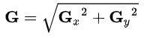

Using this information, we can also calculate the gradient's direction:

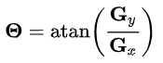

where, for example, **Θ** is 0 for a vertical edge which is lighter on the right side.  
 sobel_x = np.array([[-1, 0, 1], [-2, 0, 2], [-1, 0, 1]])  
 sobel_y = np.array([[-1, -2, -1], [0, 0, 0], [1, 2, 1]])  
 gradx3=cv.filter2D(src,cv.CV_32F,sobel_x)  
 grady3=cv.filter2D(src,cv.CV_32F,sobel_y)  
 gradx = cv.convertScaleAbs(gradx3)  
 grady = cv.convertScaleAbs(grady3)  
 cv.imshow(**"x-soble"**, gradx3)  
 cv.imshow(**"y-soble"**, grady3)  
 grad3 = cv.add(gradx3, grady3)  
 cv.imshow(**"sobel_grad"**, grad3)  
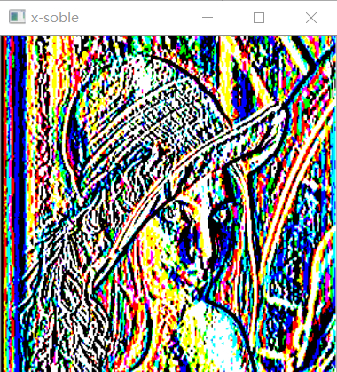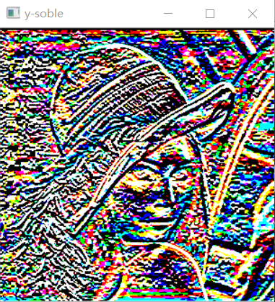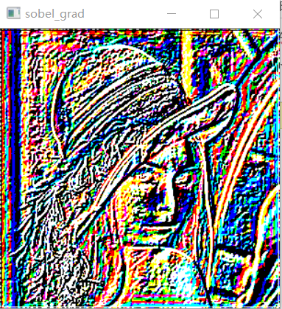

(4) The Laplace filter or discrete Laplace operator is a filter for edge detection , which approximates the Laplace operator (sum of the two pure second derivatives):

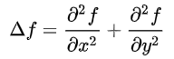

An edge is now a curve along which the gradient of the image always points in the normal direction. The vector field f is thus source-free in the area of the edge. An edge can only be adjusted if the following equation is satisfied:

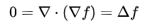

So one looks for the zero crossings of a Laplace filtered image. However, it should be noted that too  homogeneous surfaces are equal to zero. The Laplace filter thus only provides a superset of the possible edges.

The adjacent figure shows a noisy signal from which the second derivative was calculated. The edge appears here as the zero crossing of the signal. On a discrete signal gn or gnm , the Laplace operator is applied via a convolution . You can use the following simple folding masks :

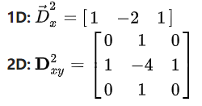

For the 2D filter, there is a second variant which, in contrast to the upper variant, also responds to 45 ° edges:

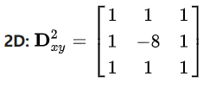

These convolution masks are obtained by discretizing the difference quotients. At the end of the article you can see examples of the application of the Laplace filter.  
 lap_4 = np.array([[0, -1, 0], [-1, 4, -1], [0, -1, 0]])  
 lap_8 = np.array([[-1, -1, -1], [-1, 8, -1], [-1, -1, -1]])  
 edge = cv.filter2D(src, cv.CV_32F, lap_8)  
 edge = cv.convertScaleAbs(edge)  
 cv.imshow(**"Laplacian8_edge"**, edge)  
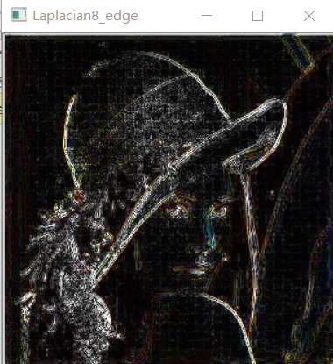  
**if** __name__ ==**"__main__"**:  
 gradient_demo()  
 cv.waitKey(0)  
 cv.destroyAllWindows()

(5) The Canny edge detector is an edge detection operator that uses a multi-stage algorithm to detect a wide range of edges in images. Canny edge detection is a technique to extract useful structural information from different vision objects and dramatically reduce the amount of data to be processed. It has been widely applied in various computer vision systems. Canny has found that the requirements for the application of edge detection on diverse vision systems are relatively similar. Thus, an edge detection solution to address these requirements can be implemented in a wide range of situations. The general criteria for edge detection include:

1. Detection of edge with low error rate, which means that the detection should accurately catch as many edges shown in the image as possible
2. The edge point detected from the operator should accurately localize on the center of the edge.
3. A given edge in the image should only be marked once, and where possible, image noise should not create false edges.
4. To satisfy these requirements Canny used the calculus of variations – a technique which finds the function which optimizes a given functional. The optimal function in Canny's detector is described by the sum of four exponential terms, but it can be approximated by the first derivative of a Gaussian.

Among the edge detection methods developed so far, Canny edge detection algorithm is one of the most strictly defined methods that provides good and reliable detection. Owing to its optimality to meet with the three criteria for edge detection and the simplicity of process for implementation, it became one of the most popular algorithms for edge detection.

The Process of Canny edge detection algorithm can be broken down to 5 different steps:

1. Apply Gaussian filter to smooth the image in order to remove the noise
2. Find the intensity gradients of the image
3. Apply non-maximum suppression to get rid of spurious response to edge detection
4. Apply double threshold to determine potential edges
5. Track edge by hysteresis: Finalize the detection of edges by suppressing all the other edges that are weak and not connected to strong edges.

**import** cv2 **as** cv  
**import** numpy **as** np  
**def** do_nothing(p):  
 **pass  
def** edge_demo():  
 src = cv.imread(**"D:/picture1/lena2.jpg"**)  
 cv.imshow(**"input"**, src)  
 cv.namedWindow(**"edge"**, cv.WINDOW_AUTOSIZE)  
 cv.createTrackbar(**"low"**, **"edge"**, 100, 300, do_nothing)  
 **while True**:  
 low = cv.getTrackbarPos(**"low"**, **"edge"**)  
 edge = cv.Canny(src, low, low * 2)  
 dst = cv.bitwise_and(src, src, mask=edge)  
 cv.imshow(**"edge"**, dst)  
 c = cv.waitKey(10)  
 **if** c == 27:  
 **break  
if** __name__ ==**"__main__"**:  
 edge_demo()  
 cv.waitKey(0)  
 cv.destroyAllWindows()

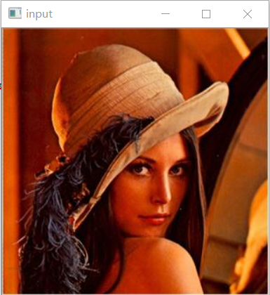 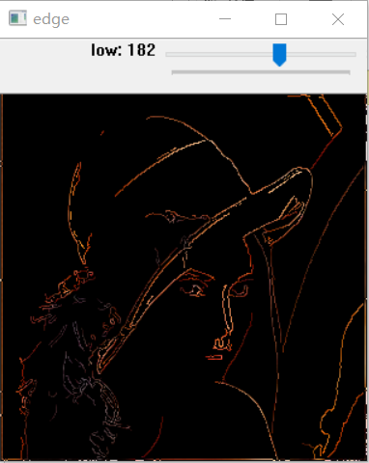

## 1.3 Comparison of several operators

The Robert operator is more accurate, but it is more sensitive to noise because it does not include smoothing. Both the Prewitt operator and the Sobel operator are first-order differential operators, while the former is average filtering, the latter is weighted average filtering and the detected image edges may be larger than 2 pixels. Both of them have a good detection effect on gray-graded and low-noise images, but the processing effect is not ideal for images with multiple complex noises. Therefore, there is a contradiction between edge positioning accuracy and noise elimination level. The noise level and edge point positioning accuracy requirements should be appropriately selected according to specific problems. Several commonly used edge detection operators are discussed and compared. The gradient operator is simple to calculate, but the accuracy is not high, only the outline of the image can be detected, and the thinner edges may be ignored. The Prewitt and Sobel operators work better than Roberts. Different systems, for different environmental conditions and requirements, select the appropriate operator to perform edge detection on the image.

1. Geometrical transformation of the image (Data augmetation).

Geometrical transformation of the image (Data augmetation). Implementation 5 or more methods for geometrical transformation.

**import** cv2 **as** cv  
**import** numpy **as** np  
**def** mirror_demo():  
 src= cv.imread(**"D:/picture1/lena2.jpg"**)  
 h, w, ch = src.shape  
 cv.imshow(**"input"**, src)  
 dst=np.zeros(src.shape,src.dtype)  
 **for** row **in** range(h):  
 **for** col **in** range(w):  
 b,g,r=src[row,col]  
 *#dst[row,w-col-1]=[b,g,r]#y_flit  
 #dst[h-row-1,col]=[b,g,r]#x_flit* dst[h-row-1,w-col-1]=[b,g,r]*#xy_flit dst=cv.flip(scr,-1)* cv.imshow(**"flit"**,dst)  
**if** __name__ == **"__main__"**:  
 mirror_demo()  
 cv.waitKey(0)  
 cv.destroyAllWindows()

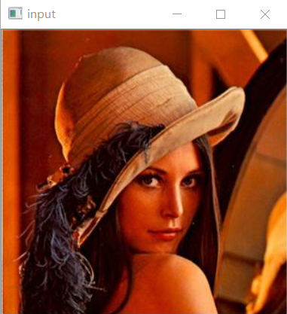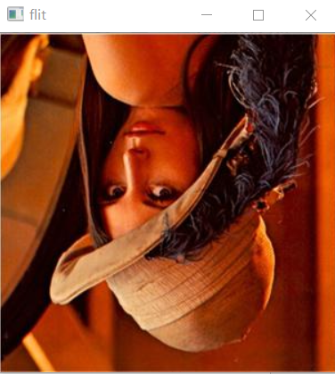

**import** cv2 **as** cv  
**import** numpy **as** np  
**def** rotate_demo():  
 src = cv.imread(**"D:/picture1/lena2.jpg"**)  
 cv.imshow(**"input"**, src)  
 dst=cv.rotate(src,cv.ROTATE_90_CLOCKWISE)  
 cv.imshow(**"rotate"**,dst)  
 h,w,ch=src.shape  
 M=cv.getRotationMatrix2D((w//2,h//2),45,1.0)  
 cos=np.abs(M[0,0])  
 sin = np.abs(M[0, 1])  
 nw = np.int(h * sin + w * cos)  
 nh = np.int(h * cos + w * sin)  
 M[0,2]+=(nw/2)-w//2  
 M[1,2]+=(nh/2)-h//2  
 dst2=cv.warpAffine(src,M,(nw,nh))  
 cv.imshow(**"rotate2"**,dst2)  
**if** __name__ == **"__main__"**:  
 rotate_demo()  
 cv.waitKey(0)  
 cv.destroyAllWindows()

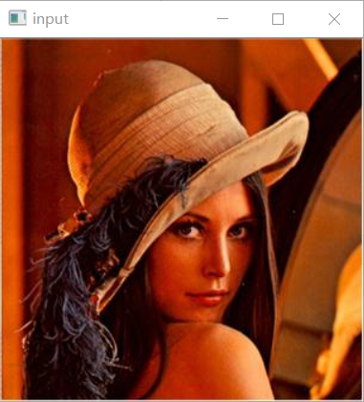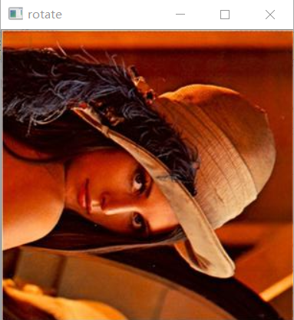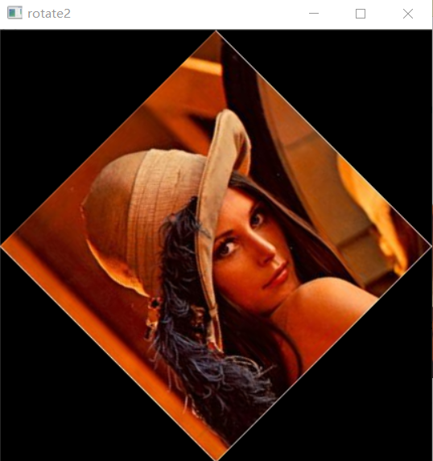

**import** cv2 **as** cv  
**import** numpy **as** np  
**def** resize_image():  
 src = cv.imread(**"D:/picture1/lena2.jpg"**)  
 cv.imshow(**"input"**, src)  
 h,w=src.shape[:2]  
 print(h,w)  
 dst=cv.resize(src,(w*2,h*2),interpolation=cv.INTER_NEAREST)  
 cv.imshow(**"dst"**,dst)  
**if** __name__ == **"__main__"**:  
 resize_image()  
 cv.waitKey(0)  
 cv.destroyAllWindows()

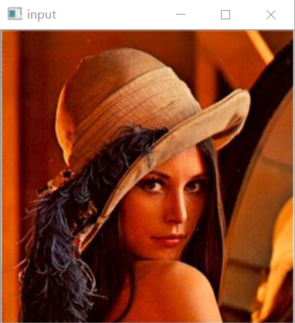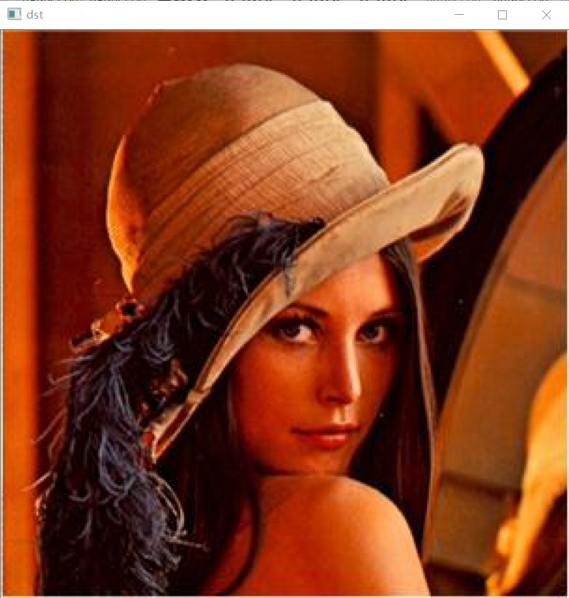

**import** cv2 **as** cv  
**import** numpy **as** np  
**def** translate_image():  
 src=cv.imread(**"D:/picture1/lena2.jpg"**)  
 cv.imshow(**"input"**, src)  
 h,w=src.shape[:2]  
 M=np.float32([[1,0,100],[0,1,100]])  
 dst=cv.warpAffine(src,M,(w,h))  
 cv.imshow(**"result"**,dst)  
**if** __name__ == **"__main__"**:  
 translate_image()  
 cv.waitKey(0)  
 cv.destroyAllWindows()

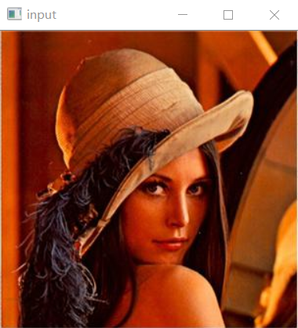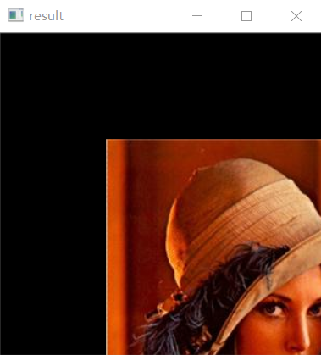

# 2.Tempate matching

Tempate matching. Implementation algorithm for finding small picture (pattern) on a big image.

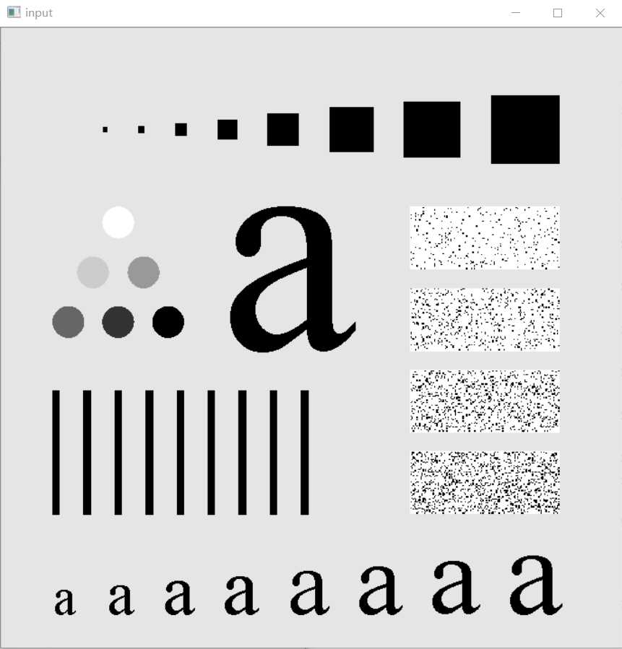 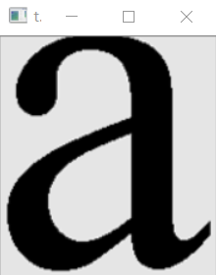 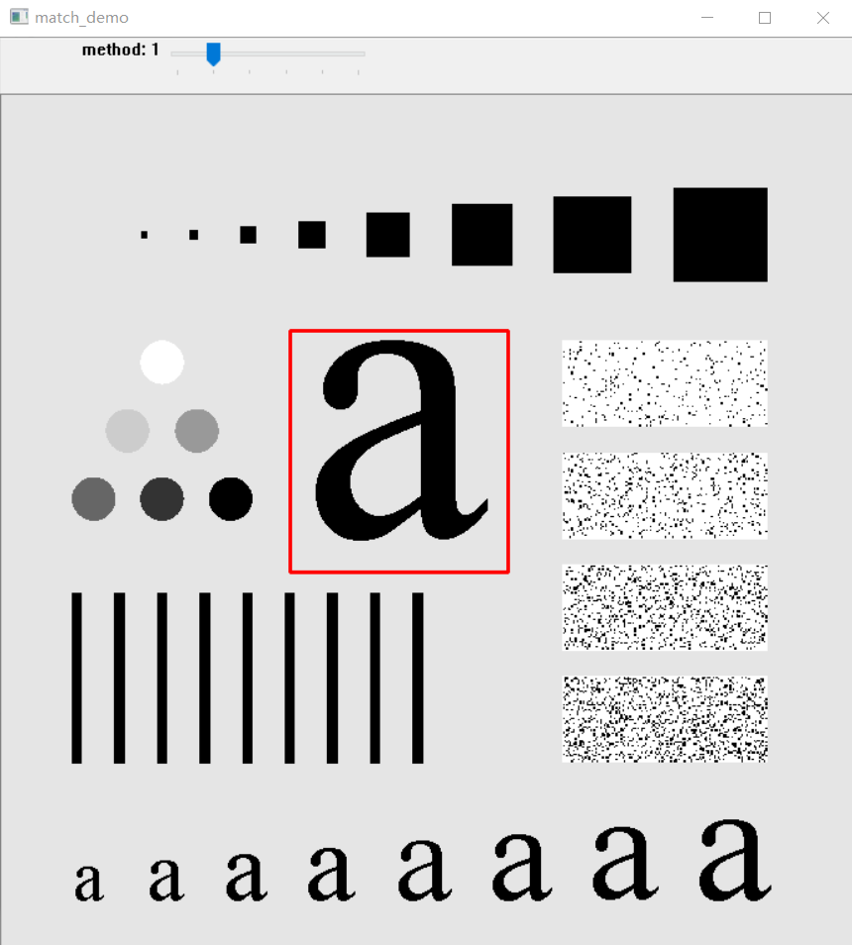

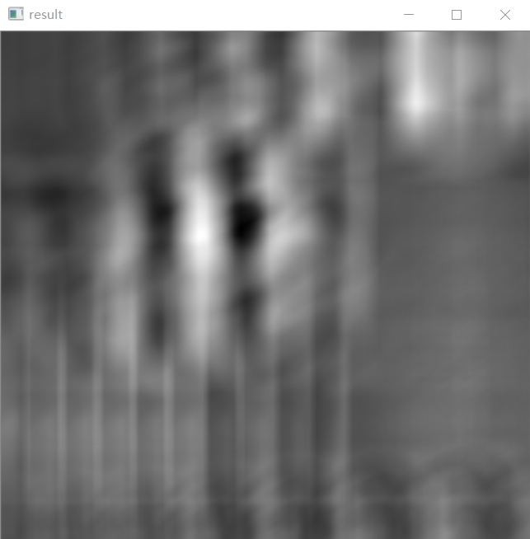

# 3.The sudy of adaptive methods of image thresholding (binary segmentation).

The sudy of adaptive methods of image thresholding (binary segmentation). Implementation 2 or more adaptive methods for binary segmentation (Isodata, Li, mean, minimum, Yen).

**import** cv2 **as** cv  
**import** numpy **as** np  
**def** threshold_method_demo():  
 src = cv.imread(**"D:/picture1/guang.tif"**, cv.IMREAD_GRAYSCALE)  
 cv.imshow(**"input"**, src)  
 dst = cv.adaptiveThreshold(src, 255, cv.ADAPTIVE_THRESH_GAUSSIAN_C, cv.THRESH_BINARY, 25, 10)  
 cv.imshow(**"binary"**, dst)  
**if** __name__ == **"__main__"**:  
 threshold_method_demo()  
 cv.waitKey(0)  
 cv.destroyAllWindows()

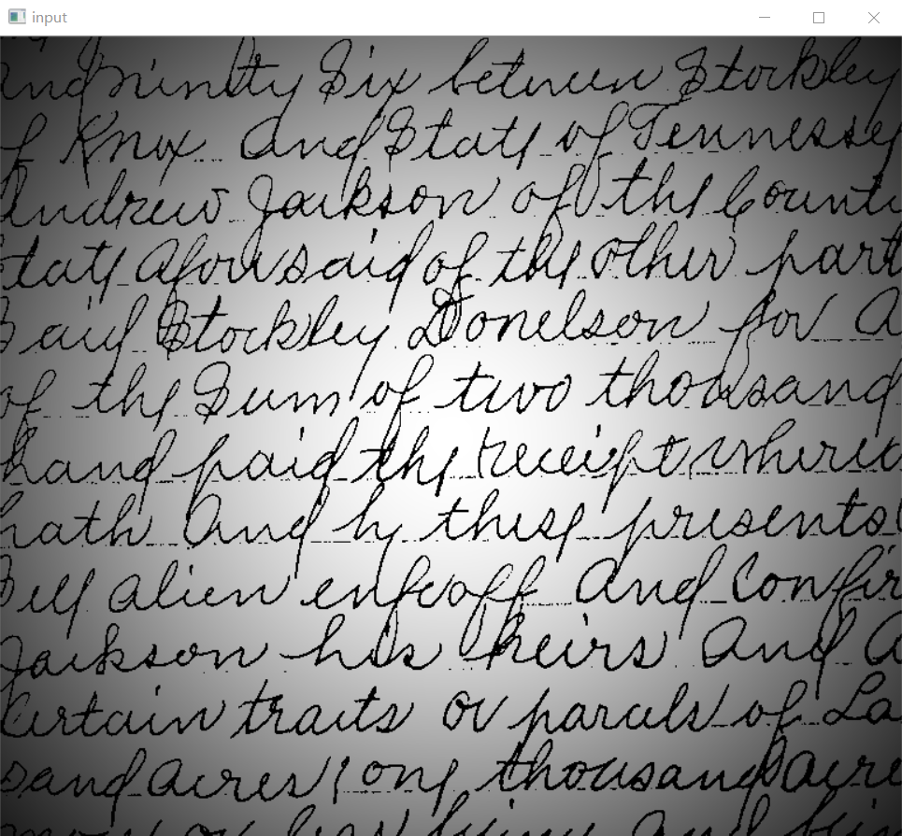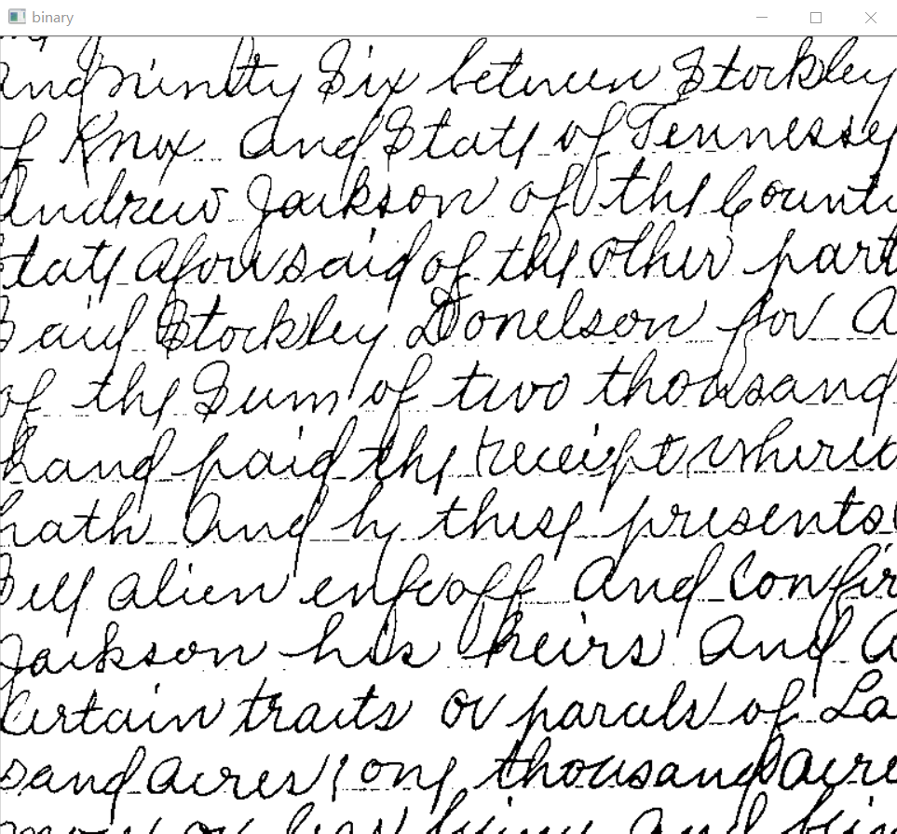

**import** cv2 **as** cv  
**import** numpy **as** np  
**def** threshold_segmentation_demo():  
 src = cv.imread(**"D:/picture1/guang.tif"**, cv.IMREAD_GRAYSCALE)  
 cv.imshow(**"input"**, src)  
 ret, dst = cv.threshold(src, 0, 255, cv.THRESH_BINARY | cv.THRESH_OTSU)  
 cv.imshow(**"binary"**, dst)  
 print(**"threshold value:"**, ret)  
**if** __name__ == **"__main__"**:  
 threshold_segmentation_demo()  
 cv.waitKey(0)  
 cv.destroyAllWindows()

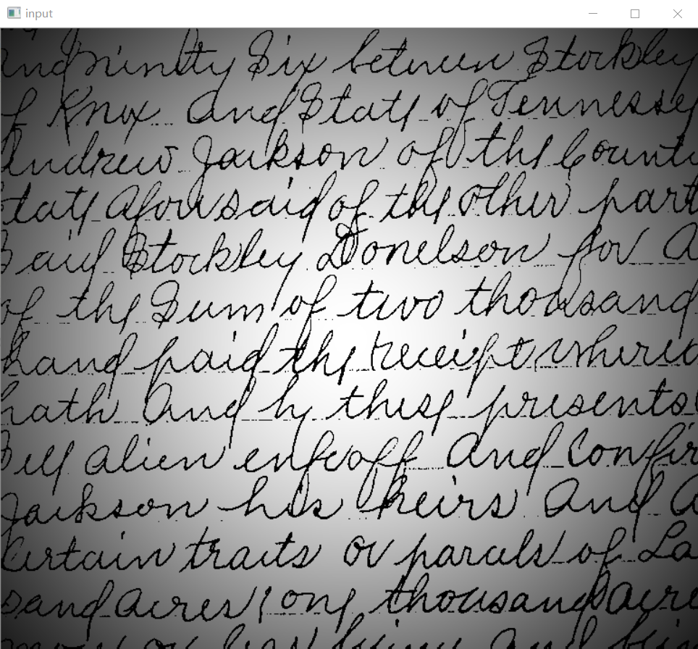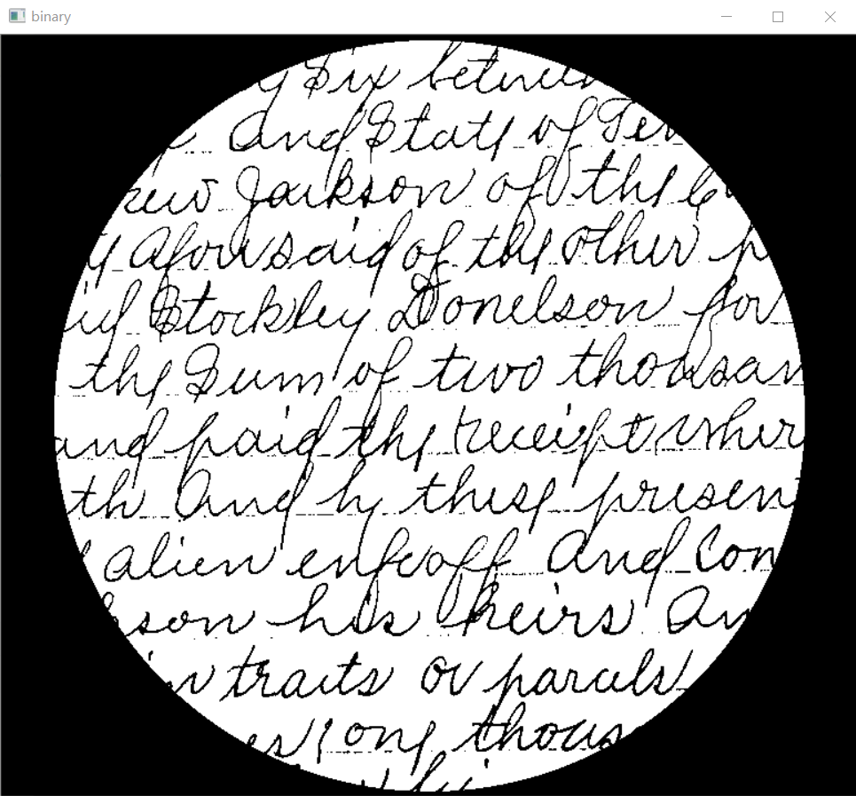

# 4.Finding objects with nessesery shape in the image (for instance, circle, rectangle, etc.).

**import** cv2 **as** cv  
**import** numpy **as** np  
**def** hough_circle_demo():  
 src = cv.imread(**"D:/picture1/coin.tif"**)  
 cv.imshow(**"input"**, src)  
 gray = cv.cvtColor(src, cv.COLOR_BGR2GRAY)  
 gray = cv.fastNlMeansDenoising(gray, **None**, 15, 10, 30)  
 rows, cols = gray.shape  
 print(rows / 8)  
 circles = cv.HoughCircles(gray, cv.HOUGH_GRADIENT, 1, rows / 8, **None**, param1=100, param2=30, minRadius=10,  
 maxRadius=50)  
 print(circles)  
 **if** circles **is not None**:  
 **for** i **in** circles[0, :]:  
 center = (i[0], i[1])  
 raidus = i[2]  
 cv.circle(src, center, 2, (0, 0, 255), -1, 8, 0)  
 cv.circle(src, center, raidus, (0, 255, 255), 2, 8, 0)  
 cv.imshow(**"circles"**, src)  
**if** __name__ == **"__main__"**:  
 hough_circle_demo()  
 cv.waitKey(0)  
 cv.destroyAllWindows()

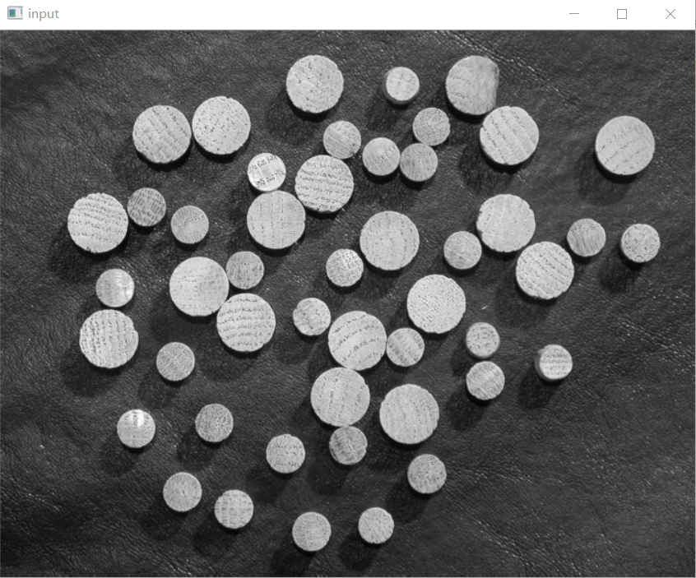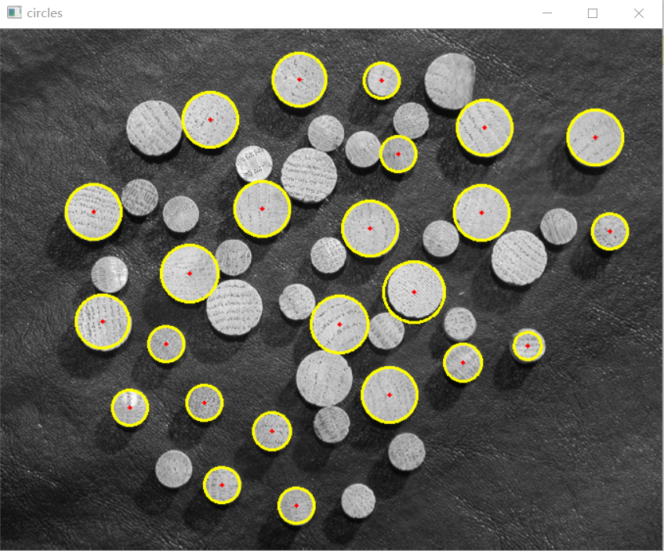

# 5.Implementation of random walker segmentation.

The random walker algorithm 1 determines the segmentation of an image from a set of markers labeling several phases (2 or more). An anisotropic diffusion equation is solved with tracers initiated at the markers’ position. The local diffusivity coefficient is greater if neighboring pixels have similar values, so that diffusion is difficult across high gradients. The label of each unknown pixel is attributed to the label of the known marker that has the highest probability to be reached first during this diffusion process.

In this example, two phases are clearly visible, but the data are too noisy to perform the segmentation from the histogram only. We determine markers of the two phases from the extreme tails of the histogram of gray values, and use the random walker for the segmentation.

A random walk is a mathematical object, known as a stochastic or random process, that describes a path that consists of a succession of random steps on some mathematical space such as the integers. An elementary example of a random walk is the random walk on the integer number line, which starts at 0 and at each step moves +1 or -1 with equal probability. Other examples include the path traced by a molecule as it travels in a liquid or a gas, the search path of a foraging animal, the price of a fluctuating stock and the financial status of a gambler can all be approximated by random walk models, even though they may not be truly random in reality. As illustrated by those examples, random walks have applications to many scientific fields including ecology, psychology, computer science, physics, chemistry, biology as well as economics. Random walks explain the observed behaviors of many processes in these fields, and thus serve as a fundamental model for the recorded stochastic activity. As a more mathematical application, the value of pi can be approximated by the usage of random walk in agent-based modelling environment.

Enough with the boring theory. Let’s take a break while getting some knowledge for the code. So, to code out the random walk we will basically require some libraries in python some to do maths and some others to plot the curve.

**import** random  
**import** numpy **as** np  
**import** matplotlib.pyplot **as** plt  
*# Probability to move up or down*prob = [0.05, 0.95]  
*# statically defining the starting position*start = 2  
positions = [start]  
*# creating the random points*rr = np.random.random(1000)  
downp = rr < prob[0]  
upp = rr > prob[1]  
**for** idownp, iupp **in** zip(downp, upp):  
 down = idownp **and** positions[-1] > 1  
 up = iupp **and** positions[-1] < 4  
 positions.append(positions[-1] - down + up)  
*# plotting down the graph of the random walk in 1D*plt.plot(positions)  
plt.show()

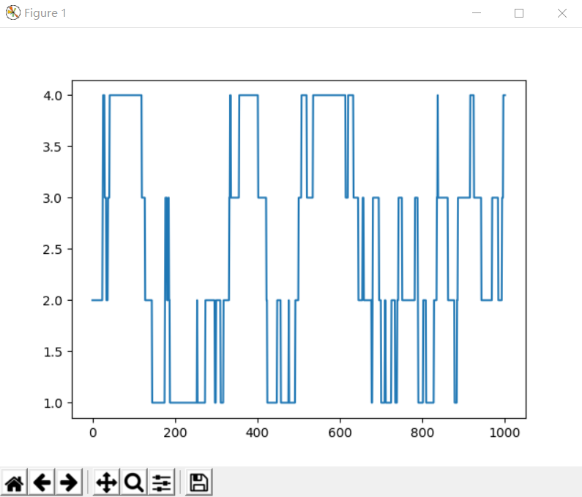

**import** numpy  
**import** pylab  
**import** random  
*# defining the number of steps*n = 100000  
*# creating two array for containing x and y coordinate  
# of size equals to the number of size and filled up with 0's*x = numpy.zeros(n)  
y = numpy.zeros(n)  
*# filling the coordinates with random variables***for** i **in** range(1, n):  
 val = random.randint(1, 4)  
 **if** val == 1:  
 x[i] = x[i - 1] + 1  
 y[i] = y[i - 1]  
 **elif** val == 2:  
 x[i] = x[i - 1] - 1  
 y[i] = y[i - 1]  
 **elif** val == 3:  
 x[i] = x[i - 1]  
 y[i] = y[i - 1] + 1  
 **else**:  
 x[i] = x[i - 1]  
 y[i] = y[i - 1] - 1  
*# plotting stuff:*pylab.title(**"Random Walk ($n = "** + str(n) + **"$ steps)"**)  
pylab.plot(x, y)  
pylab.savefig(**"rand_walk"** + str(n) + **".png"**, bbox_inches=**"tight"**, dpi=600)  
pylab.show()

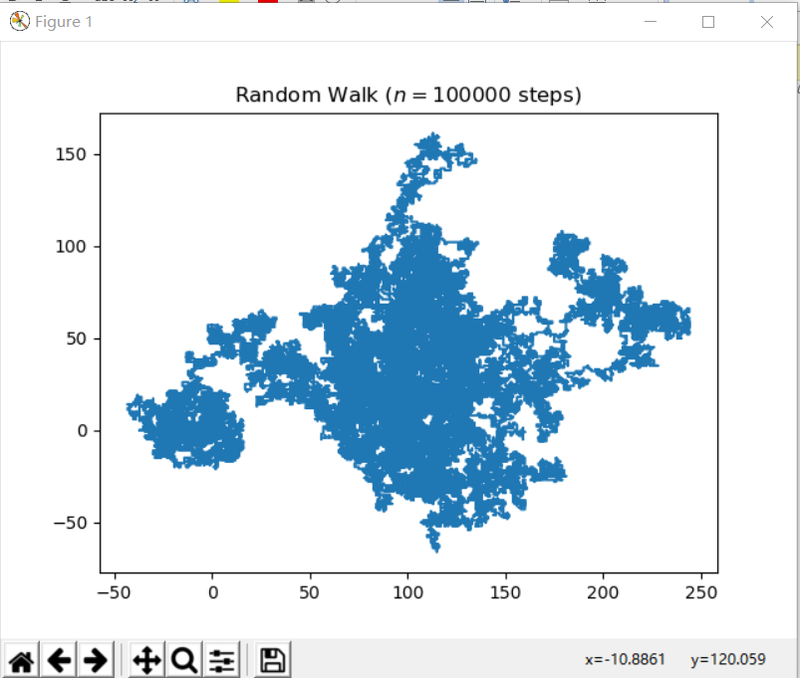

# 6.Implementation of watershed segmentation.

Any grayscale image can be viewed as a topographic surface where high intensity denotes peaks and hills while low intensity denotes valleys. You start filling every isolated valleys (local minima) with different colored water (labels). As the water rises, depending on the peaks (gradients) nearby, water from different valleys, obviously with different colors will start to merge. To avoid that, you build barriers in the locations where water merges. You continue the work of filling water and building barriers until all the peaks are under water. Then the barriers you created gives you the segmentation result. This is the "philosophy" behind the watershed.

But this approach gives you oversegmented result due to noise or any other irregularities in the image. So OpenCV implemented a marker-based watershed algorithm where you specify which are all valley points are to be merged and which are not. It is an interactive image segmentation. What we do is to give different labels for our object we know. Label the region which we are sure of being the foreground or object with one color (or intensity), label the region which we are sure of being background or non-object with another color and finally the region which we are not sure of anything, label it with 0. That is our marker. Then apply watershed algorithm. Then our marker will be updated with the labels we gave, and the boundaries of objects will have a value of -1.

**import** numpy **as** np  
**import** cv2 **as** cv  
**from** matplotlib **import** pyplot **as** plt  
img = cv.imread(**'D:/picture1/coin.tif'**)  
plt.figure(num=1,figsize=(10,40))  
plt.subplot(321)  
plt.imshow(img)  
gray = cv.cvtColor(img,cv.COLOR_BGR2GRAY)  
ret, thresh = cv.threshold(gray,0,255,cv.THRESH_BINARY_INV+cv.THRESH_OTSU)  
plt.subplot(322)  
plt.imshow(thresh)  
*# noise removal*kernel = np.ones((3,3),np.uint8)  
opening = cv.morphologyEx(thresh,cv.MORPH_OPEN,kernel, iterations = 2)  
*# sure background area*sure_bg = cv.dilate(opening,kernel,iterations=3)  
*# Finding sure foreground area*dist_transform = cv.distanceTransform(opening,cv.DIST_L2,5)  
ret, sure_fg = cv.threshold(dist_transform,0.7*dist_transform.max(),255,0)  
*# Finding unknown region*sure_fg = np.uint8(sure_fg)  
unknown = cv.subtract(sure_bg,sure_fg)  
plt.subplot(323)  
plt.imshow(unknown)  
*# Marker labelling*ret, markers = cv.connectedComponents(sure_fg)  
*# Add one to all labels so that sure background is not 0, but 1*markers = markers+1  
*# Now, mark the region of unknown with zero*markers[unknown==255] = 0  
plt.subplot(324)  
plt.imshow(markers,cmap=**"rainbow"**)  
markers = cv.watershed(img,markers)  
plt.subplot(325)  
plt.imshow(markers)  
img[markers == -1] = [255,0,0]  
plt.subplot(326)  
plt.imshow(img)  
plt.show()

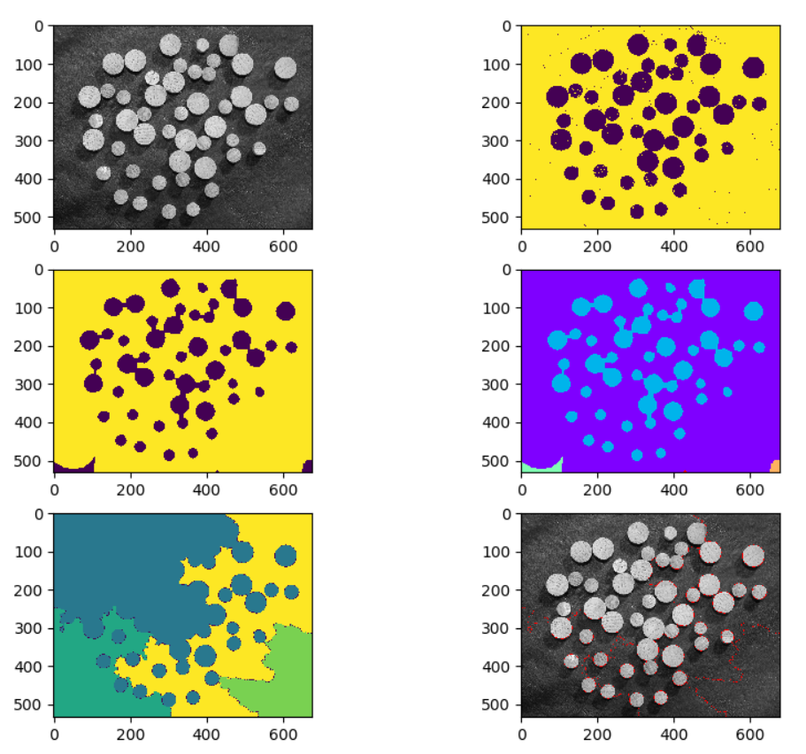

# 7. Implementation of object tracking.

**import** cv2 **as** cv  
**import** numpy **as** np  
**def** video_io_demo():  
 capture = cv.VideoCapture(**"D:/video1/fbb.mp4"**)  
 *# capture = cv.VideoCapture(0)* height = capture.get(cv.CAP_PROP_FRAME_HEIGHT)  
 width = capture.get(cv.CAP_PROP_FRAME_WIDTH)  
 count = capture.get(cv.CAP_PROP_FRAME_COUNT)  
 fps = capture.get(cv.CAP_PROP_FPS)  
 print(height, width, count, fps)  
 *#out = cv.VideoWriter("D:/test.mp4", cv.VideoWriter_fourcc('D', 'I', 'V', 'X'), 15, (np.int(width), np.int(height)), True)* **while**(**True**):  
 ret, frame = capture.read()  
 **if** ret **is True**:  
 cv.imshow(**"video-input"**, frame)  
 result =detect_face(frame)  
 cv.imshow(**"video-result"**, result)  
 c = cv.waitKey(20)  
 *#out.write(frame)* **if** c == 27: *#ESC* **break  
 else**:  
 **break  
  
def** detect_face(frame):  
 gray = cv.cvtColor(frame, cv.COLOR_BGR2GRAY)  
 cv.equalizeHist(gray, gray)  
 faces = face_detector.detectMultiScale(gray, 1.2, 1, minSize=(40, 40), maxSize=(300, 300))  
 **for** x, y, w, h **in** faces:  
 cv.rectangle(frame, (x, y), (x+w, y+h), (0, 0, 255), 2, 8, 0)  
 **return** frame  
  
**if** __name__ == **"__main__"**:  
 face_detector = cv.CascadeClassifier(**"E:/Python Worker/opencv-3.4/data/haarcascades/haarcascade_frontalface_alt_tree.xml"**)  
 *#face_detector = cv.CascadeClassifier("E:/Python Worker/opencv-master/data/lbpcascades/lbpcascade_frontalface_improved.xml")* video_io_demo()  
 cv.waitKey(0)  
 cv.destroyAllWindows()

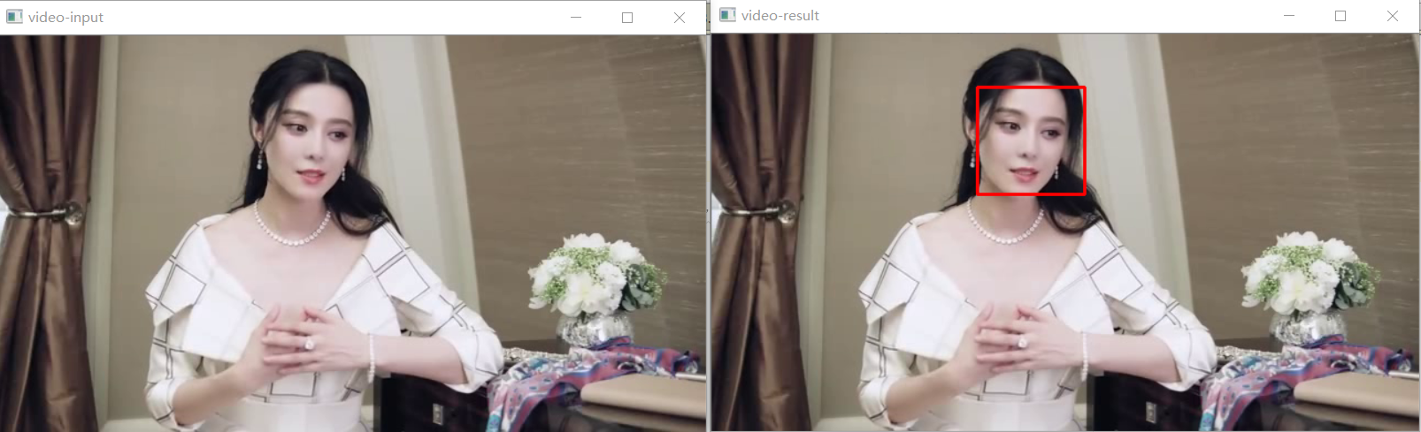

# REFERENCES

1. Leon A. Gatys, Alexander S. Ecker, Matthias Bethge «A Neural Algorithm of Artistic Style», 2015 (Access: <https://pdfs.semanticscholar.org/77c5/12cbb832436e1a35ad434e6bb3d763799763>)
2. Gurney K. “An Introduction to Neural Networks” London, 1997 (Access: <https://www.inf.ed.ac.uk/teaching/courses/nlu/reading/Gurney_et_al.pdf>)
3. Gareth James, Daniela Witten, Trevor Hastie, Robert Tibshirani “An Introduction to Statistical Learning: with Applications in R” (Access: <http://www-bcf.usc.edu/~gareth/ISL/ISLR%20First%20Printing.pdf> )
4. Stuart J. Russell, Peter Norvig “Artificial Intelligence: A Modern Approach”, 3rd edition, Prentice-Hall, 2003 (Access: <https://www.google.ru/url?sa=t&rct=j&q=&esrc=s&source=web&cd=5&sqi=2&ved=0ahUKEwin0eep9sTTAhVEXSwKHeBVAqoQFgg7MAQ&url=https%3A%2F%2Ffaculty.psau.edu.sa%2Ffiledownload%2Fdoc-7-pdf-a154ffbcec538a4161a406abf62f5b76-original.pdf&usg=AFQjCNE-JSNtyAa-RIi9e4MzACPQwYgfYA&sig2=hzOgpMkM7q1zUbyz0rpjtg>)
5. Deng Li, Yu Dong "Deep Learning: Methods and Applications”, NOW Publishers, 2014 (Access: <https://www.microsoft.com/en-us/research/wp-content/uploads/2016/02/DeepLearning-NowPublishing-Vol7-SIG-039.pdf>)
6. Wei-Han Chang, Ming-Cheng Cheng, Chung-Ming Kuo, Guan-Da Huang «Feature-Oriented Artistic Styles Transfer Based on Effective Texture Synthesis», Ubiquitous International Volume 6, Number 1, 2015 (Access: <http://bit.kuas.edu.tw/~jihmsp/2015/vol6/JIH-MSP-2015-01-002> )
7. Ron Kohavi, Foster Provost "Glossary of terms. Machine Learning” 30, 1998 (Access: <http://ai.stanford.edu/~ronnyk/glossary.html> )
8. David J. C. MacKay. Information Theory, “Inference, and Learning Algorithms” Cambridge: Cambridge University Press, 2003 (Access: <http://www.inference.phy.cam.ac.uk/itprnn/book.pdf> )
9. Julia Patterson, B.A., «Investigation of Style Transfer on Digital Images», University of Dublin, Trinity College, 2012 (Access: <https://www.scss.tcd.ie/postgraduate/msciet/current/Dissertations/1112/Patterson> )
10. Yoshua Bengio “Learning Deep Architectures for AI”, NOW Publishers, 2009 (Access: <http://sanghv.com/download/soft/machine%20learning,%20artificial%20intelligence,%20mathematics%20ebooks/ML/learning%20deep%20architectures%20for%20AI%20%282009%29.pdf>)
11. Trevor Hastie, Robert Tibshirani and Jerome H. Friedman “The Elements of Statistical Learning”, Springer Jan 2013. (Access: <http://statweb.stanford.edu/~tibs/ElemStatLearn/printings/ESLII_print10.pdf> )